Biography 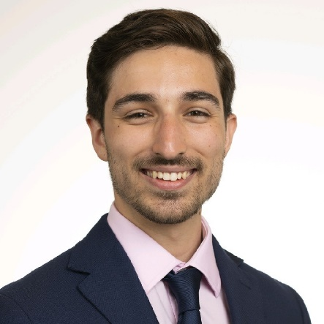
Michael Komarovsky is a third-year medical student at the Cleveland Clinic Lerner College of Medicine (CCLCM) interested in critical care. He has been working in simulation since his time as the training director of Case Western Reserve University Emergency Medical Service where he served as an emergency medical technician while obtaining his Bachelor of Arts in Physiology (2017-2021). Since receiving his undergraduate degree, Michael has worked in a variety of roles including being a medical scribe in an outpatient heart failure cardiology clinic as part of the Cleveland Clinic’s Medical Observation and Scribe Training Fellowship, publishing multiple peer-reviewed medical research articles, working as a coronary intensive care unit clinical technician, and serving as an editor and co-editor-in-chief of Stethos, the medical humanities journal of CCLCM. Recently his simulation work has centered on vascular access simulation through the CCLCM Ultrasound Interest Group and Professional Anesthesiology Interest Group as well as through a partnership with Dr. Sergio Bustamante and David Leifer in the Simulation and Advanced Skills Center where they have been providing courses on ultrasound guided vascular access and intraosseous vascular access.

